**Lab-4**

**Out Date:** 10/09/2018 (Tuesday)

**Due Date:** 10/09/2018 (Tuesday) within class time

**Problem-1 [30 points]:** Alter the code given in circle.cpp so that setting the center of the circle is also done during the object definition. This means that the constructors will also take care of this initialization. Make the default center at point (0, 0) and keep the default radius as 1. Have an object, **sphere** defined with initial values of 8 for the radius and (9, 10) for the center. How does this affect existing functions and code in the main function?

**Sample output**

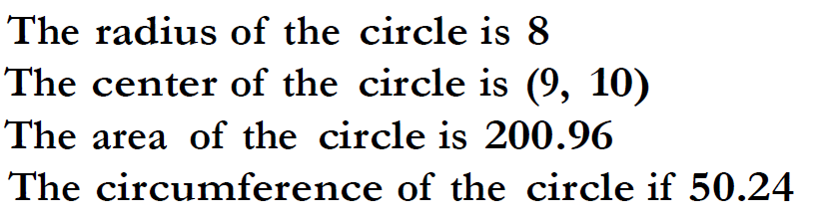

**Problem-2 [50 points]:** Perform the following operations:

* Divide the file into three files: circles.h for the class definition, circles.cpp for the class implementation and Lab4.cpp for the main program **[10 points]**.
* There can be several constructors as long as they differ in number of parameters or data type. Alter the program so that the user can enter either just the radius, the center, the radius and the center, or nothing at the time the object is defined. Whatever the user does NOT include (radius or center) must be initialized somewhere. There is no setRadius function and there will no longer be a setCenter function. You can continue to assume that the default radius is 1 and the default center is (0, 0). Alter the client portion (main) of the program by defining an object
  + **sphere1** by giving just the radius of 2,
  + **sphere2** by giving neither the radius nor the center (it uses all the default values), and
  + **sphere3** by giving the center at (15, 16).

Be sure to print out the vital statistics for these new objects (area and circumference) **[35 points].**

* Add a destructor in the program. The destructor will print this message: "This concludes the Circles class." **[5 points]**

**Sample output**

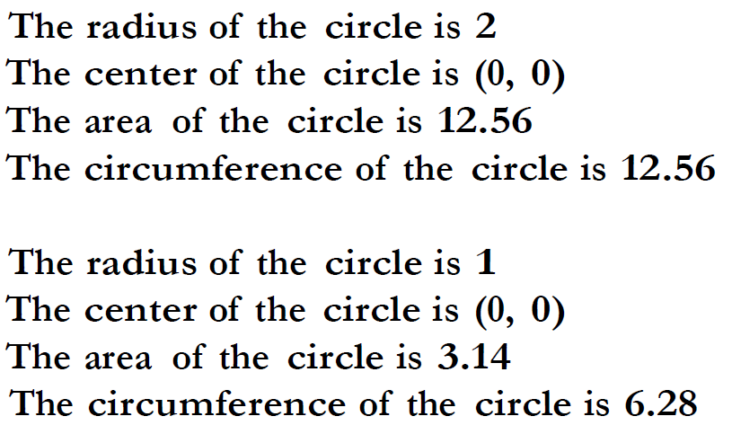

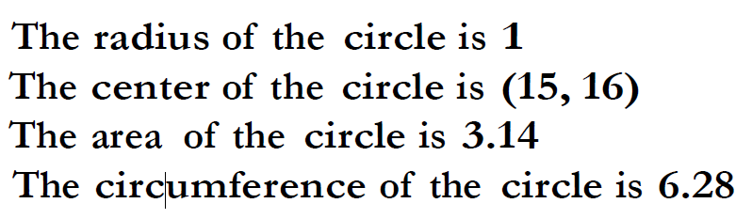

**Scoring Distribution [100 points]**

* 80 points for implementing the above mentioned requirements.
* 10 points for appropriate comments
* 10 points for programing style

**Blackboard Submission**

1. Show the working program to the instructor
2. Zip the file (**Circle.h, Circle.cpp, and Lab4.cpp**)
3. Upload it to blackboard